ENTER  The Woman Who Achieves Awards 2024  I Am A Man Who Award | 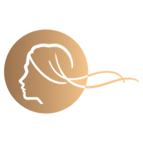

I Am A Man Who… is awarded to a Man Who supports women in business. There is no specific criteria, however the nomination should tell the Judges enough to be able to see that this is a Man Who shares Woman Who values and does amazing things to support women in business initiatives.

MAN WHO… DETAILS
Name:
Business Name (if applicable):
Email:
Post Code:

About the Man Who… | Tell us about the Man Who… Who he is, what he does (max 500 words)

Why is he a Man Who…? | Tell us about how the Man Who supports women in business (max 500 words)

Achievements | Tell us about his achievements (max 150 words)

WEBSITE & SOCIALS
Website:
LinkedIn:

Submit your completed form to: admin@womanwho.co.uk by midnight on Sunday 3rd March 2024.

By submitting your entry for these Awards, you confirm that, if you are selected as a finalist, you are available to attend the Awards Lunch on Friday 10th May 2024 at Coombe Abbey Hotel, Warwickshire.

